More on functions

1) Write a program,

a. where the function accepts two arguments.

b. The function should multiply the two arguments.

c. Make 3 function calls with arguments - (1, 2), (2, 3) and (3, 4)

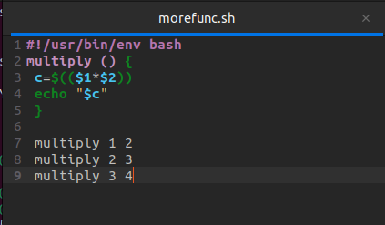

TERMINAL

